*Notice:
This file is an example based on generic satellite design and does not guarantee to be approved on the review process for launch or deployment. In accordance with design of each satellite, this document may have to be changed. Details of this template are subject to change without notice. Please change YELLOW sentence according to each satellite.
(本文書は標準的な設計の衛星を想定した一例であり、打上げ・放出のための審査プロセスでの承認を保証しているものではありません。各衛星の設計によって内容を変更する必要があります。また、本テンプレートの内容は予告なく変更される場合があります。黄色の箇所を各衛星に応じて変更してください。)

[Satellite Name]
Fit Check Test Report

Initial Release: DD/MM/YYYY

[Project Team Name]

Revision History

Version | Date | Writer | Annotations
1 | [DD/MM/YYYY] | XXX | Initial Release
1.1
1.2

Contents
1 Purpose 1
2 Applicable Document 1
3 Test Hardware List 1
4 Test method 1
4.1 General Requirements 1
4.2 Fit Check 1
4.2.1 Preparation of J-SSOD Fit Check Case 1
4.2.2 Installation of satellite into J-SSOD Fit Check Case 3
4.2.3 De-installation of the satellite from J-SSOD Fit Check Case 4
5 Test Result 4
6 Conclusion 11

Purpose
This document summarizes the result of fit check for [Satellite Name] which will be deployed from JEM Small Satellites Orbital Deployer (J-SSOD).
The fit check is conducted to inspect the satellite visually and the adequate torque with torque mark, and to confirm if the satellite can be installed into the J-SSOD with no interference.

Applicable Document
- JX-ESPC-101132-C JEM Payload Accommodation Handbook-Vol.8-
Small Satellite Deployment Interface Control Document

Test Hardware List
The following hardware is required for this test.

Table 3-1: Test Objective Hardware
Description | P/N | S/N | Preparation
CASE-1 FOR FITCHECK  (J-SSOD Fit Check Case) | 251D031005-5 | 001 | JAXA
[Satellite Name] (Flight Model) | [P/N] | [S/N] | [Satellite Developer]

Test method

General Requirements
- Personnel shall wear clean glove for handling the J-SSOD Fit Check Case
- Personnel shall wear clean glove and ESD strap for handling the satellite

Fit Check

Preparation of J-SSOD Fit Check Case
- Remove Launch Cover by loosening six(6) captive fasteners.

CAUTION:
- Since the Satellite Lock Door is pushed by the Launch Cover, it will automatically open when the Launch Cover is removed. Therefore, remove the Launch Cover slowly
- Take care for pinching by the Hook of the Satellite Lock Door when removing the Launch Cover.

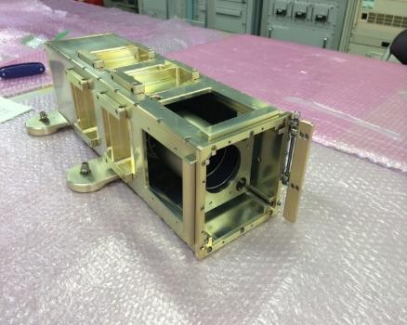

Figure 4.2.1-1: J-SSOD Fit Check Case

- If there is the Quick-Release Pin, Push Back Plate to the position for the fit check and fix the Back Plate by putting Quick-Release Pin into the corresponding hole. Refer to Figure 4.2.1-2 and 4.2.1-3.

CAUTION:
- If there is the Quick-Release Pin, there are ball bearings protruding from outer surface of the Quick-Release Pin. They can be pushed into the surface by pushing the Lock-Release Button on top of the Quick-Release Pin. Putting on and pulling away the Quick-Release Pin to/from the hole of the J-SSOD Fit Check Case shall be performed with pushing the Lock-Release Button.

- Inspect there is no debris on Rail Guides of J-SSOD Fit Check Case. If there is debris, remove it lint-free cloth or clean stick.

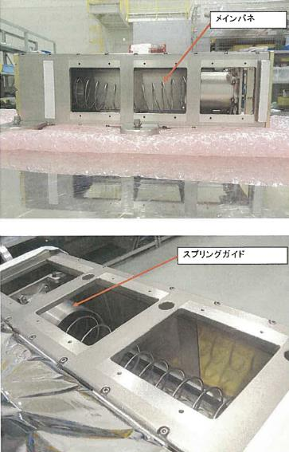
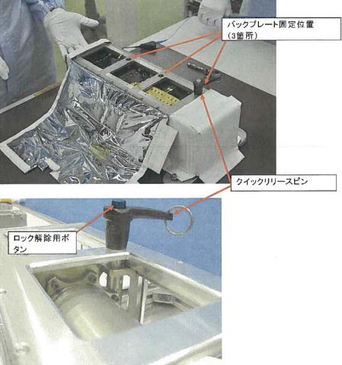
Figure 4.2.1-2: Main Spring and Spring Guide

Figure 4.2.1-3 Quick-Release Pin and Holes

Installation of satellite into J-SSOD Fit Check Case
- Inspect there is no damage and burr on the satellite rail surfaces.

- Install the satellite into the J-SSOD Fit Check Case until it touches with the Back Plate, as like Figure 4.2.2-1.

CAUTION:
- If there is Quick-Release Pin, be sure that the Quick-Release Pin is appropriately inserted into the hole.
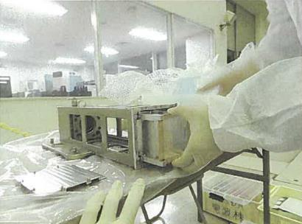
Z
X
Y

Figure 4.2.2-1: Installation of satellite into J-SSOD Fit Check Case
- Confirm that there is no interference between the satellite and J-SSOD Fit Check Case inner surface, and take photos (include status of deployment switches).

<If there is Lock Door, proceed next steps.>
- Close Satellite Lock Door.

- Confirm that there is no interference between the satellite and Satellite Lock Door, and take photos.

De-installation of the satellite from J-SSOD Fit Check Case
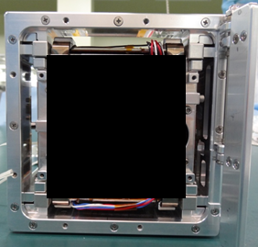
- Pull the satellite out from J-SSOD Fit Check Case by pulling the rail edges of the satellite shown in Figure 4.2.3-1.
Rail Guide
Satellite Rail Edge

Figure 4.2.3-1: Satellite Rail Edge and J-SSOD Rail Guide

Test Result

Date of fit check：[YYYY/MM/DD]
Place of fit check：[XXXX]

Dimensions of the satellite at the time of the fit check are shown below.

+X
PHOTO
Figure 5-1:Dimension for +X surface (before fit check)

-X
PHOTO
Figure 5-2: Dimension for -X surface (before fit check)
+Y
PHOTO
Figure 5-3: Dimension for +Y surface (before fit check)

-Y
PHOTO
Figure 5-4: Dimension for -Y surface (before fit check)

+Z
PHOTO
Figure 5-5: +Z Surface (before fit check)

-Z
PHOTO
Figure 5-6: -Z Surface (before fit check)

+Z
PHOTO
Satellite inside Fit Check Case
Figure 5-7: +Z surface when the satellite is stored inside the Fit Check Case

＋X
PHOTO
Figure 5-8 +X surface (after fit check)

－X
PHOTO
Figure 5-9 -X surface (after fit check)

＋Y
PHOTO
Figure 5-10 +Y surface (after fit check)

－Y
PHOTO
Figure 5-11 -Y surface (after fit check)

＋Z
PHOTO
Figure 5-12 +Z surface (after fit check)

－Z
PHOTO
Figure 5-13 -Z surface (after fit check)

Conclusion
[Satellite Name] was successfully installed inside the J-SSOD in the planned order and orientation of deployment from ISS. There was no protrusion and all success criteria were met.

